Trần Tấn Phát

2274802010644

Lab1

Bài làm

Câu a:

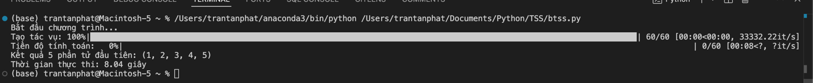

Câu b:

